

**STOKERS SIDING SCHOOL**

**NEWSLETTER**

Email address: stokerssid-p.school@det.nsw.edu.au

Web Page: http://www.stokerssid-p.schools.nsw.edu.au/Index.html

**Term 4 Week 4 - Wednesday 3rd November 2010**

|  |  |  |  |
| --- | --- | --- | --- |
| **DATE** | **EVENT** | **WHO** | **ACTION** |
| **15/10/10** | **AFL Clinic**  **12 – 1.30**  **(6 week program)** | **All classes** | **Joggers or school shoes** |
| **5/11/10** | **Show Relay Team** | **4 students**  **Plus 2 emergencies** | **Parents and teacher to attend with students.** |
| **16/11/10** | **Art Gallery Excursion** | **K-3 Students** | **More info at a later date.** |

**PRINCIPAL’S MESSAGE**

As you are aware, Marg is on leave for the next two weeks, so I am holding the reins. Ms Withers will be replacing Marg in a variety of roles and she will also be working with K/1/2 when there are things that need to be done in the Office. Welcome back Robyn! Last Friday was the last day for our two Student teachers, Ms Treasure and Ms Taylor – they gained a great deal from their three weeks with us and they were especially impressed with the behaviour and enthusiasm of our children. Well done kids! Last Thursday was our school Trivia day and what a great time we had – thanks to all parents who assisted with our spooky costumes. A total of $25 was raised for Camp Quality – thanks everyone. Our annual P&C Trivia night was held on Saturday night. Many thanks to Nicole, Nell and Debby for making the evening such a success and to all those involved in decorating the Hall – it looked fantastically scary! Thank you to all the businesses and individuals who donated prizes for the night, we really appreciate your support. Four of our children will be representing our school at the Murwillumbah Show relay competition on Friday. Best of luck everyone! The children are all enjoying our AFL Clinic – their skills are improving noticeably each week. Thanks once again to Ken Dewar for the fantastic work you’ve done in getting our vegetable gardens up and running - K/ 1/2 were very enthusiastic planters last week! We have lettuce, corn, tomatoes and spinach growing.

**Merit Awards**

Congratulations to our Merit Award winners for this week – Micheal Woodgate, Tahneyah van Zanden, Kahani Flanagan, Lily Axford and Tahlia Dilati. Special congratulations to **Marcus Pearson** who is our Student of the Week.

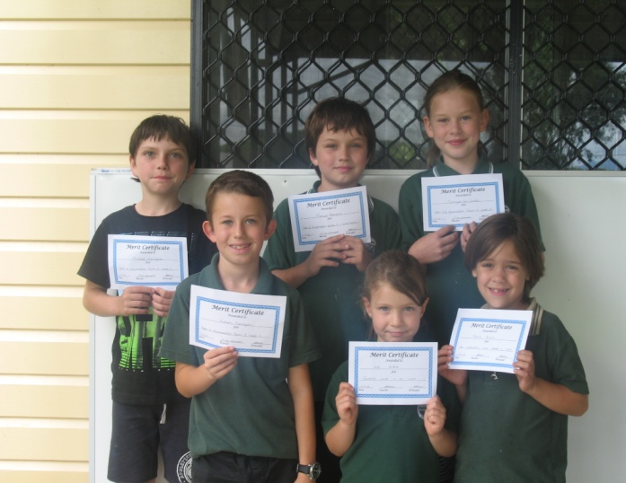 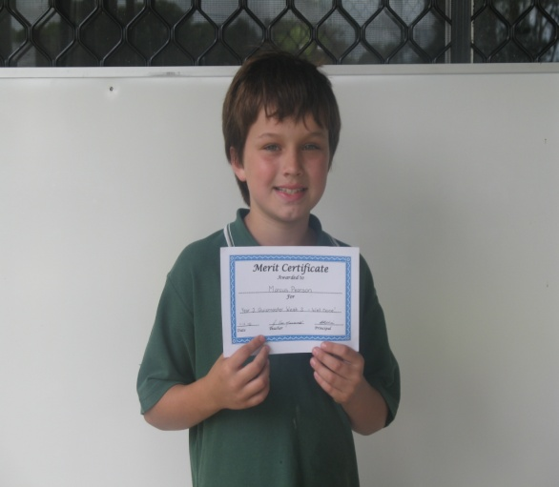

**C:\Program Files\Microsoft Expression\Web 2\MEDIA\CAGCAT10\j0305493.wmfTrivia Night**

Saturday night was full of fun and laughs as the P&C hosted our annual Trivia Night. We had lots of witches, devils and even “The Bride of Frankenstein” attended. The night raised over $900 this money will be used to purchase a PA System for the school.

The P&C would like to thank all who attended and all the local businesses for their support. A list of the businesses who donated prizes is attached to the newsletter. I would like to personally thank Debby and Nell for the huge amount of help in organising the night. Also thanks to Michelle, Rohan, Judith, Nell and their children for helping to decorate the hall.

**Nicole Morris**

**Canteen News**

Canteen Roster for Friday 5th Nov – Sonia and Rohan

**More volunteers needed.**

**Kindy Orientation**

Our Kindergarten Orientation program is running really well – last week we made school buses and learnt some new songs and dances. “Singing in the Rain” is already a favourite! It’s wonderful to have such a large Kindergarten group – we have 13 happy, energetic young learners starting school in 2011!

Timetable as follows:

For the next two weeks the children will be at school until 11 a.m. (5th and 12th November)

The next two weeks the children will be at school until 11.30a.m. (19th and 26th of November)

On the 3rd of December the children will stay and have Fruito and morning tea with us, until midday.

On the 10th of December this will be extended to lunchtime (1.30p.m.) depending on how we settle in.

The aim of our orientation program is to make starting at “big school” a happy, relaxed and worry-free time for all.

Mr Killion.

The Sports for School vouchers program finished on 31st October, so you won’t be given any more at the checkout. However:

**All Coles Sports for Schools Vouchers need to be returned by Friday 5th Nov.**

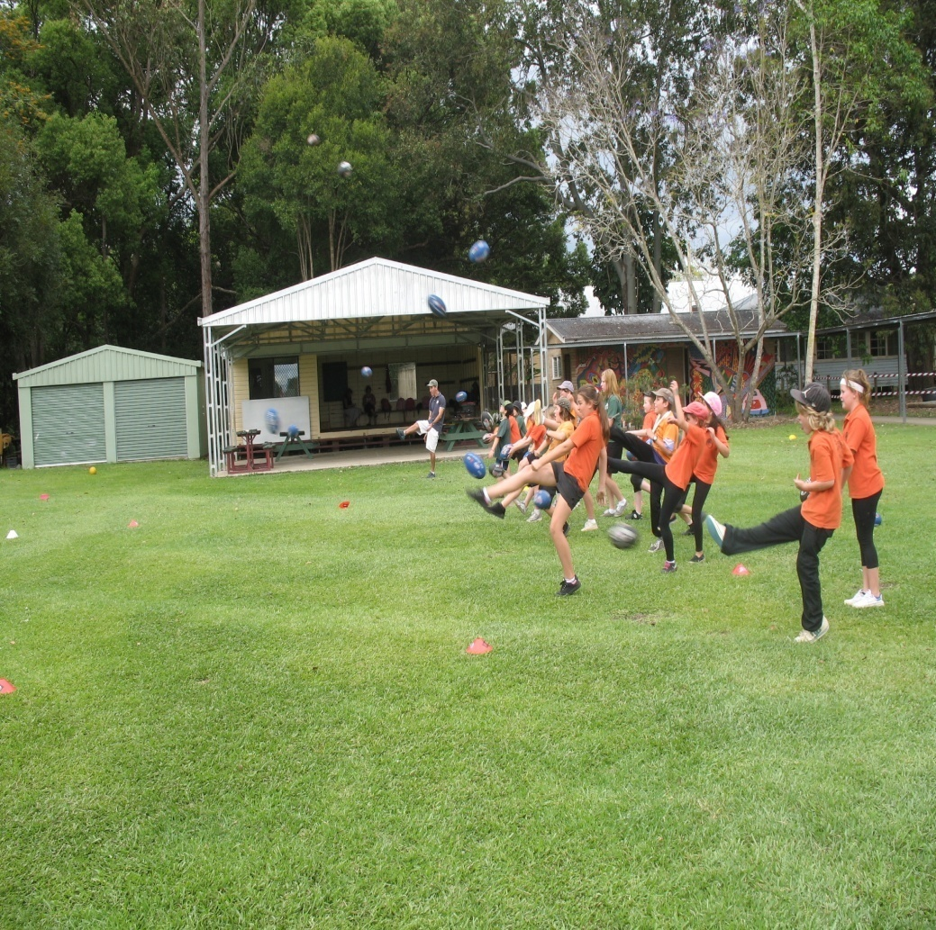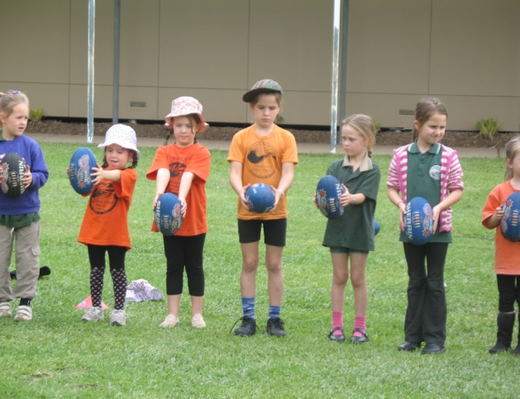

**Community News**

**Junior Cricketers**

Under 16-14-12

Beginners Under 10 – Training Rabjones Oval Murwillumbah Tue/Thur 3.45-5.15 Membership Fee $90 Further details

Phone: 66770186

**Southern Cross Cultural Exchange**

We are seeking volunteer host families for selected international exchange students from European countries, the USA and Japan arriving in early February. Match a student to your family.

Ring 1800500501 or [scceaust@scce.com.au](mailto:scceaust@scce.com.au)

**House to rent: farm house on house block for rent in Stokers Siding. Phone 0400415167**

Richard Killion

(Relieving) Principal

Some memories of our Trivia Day 