

**STOKERS SIDING SCHOOL**

**NEWSLETTER**

Email address: stokerssid-p.school@det.nsw.edu.au

Web Page: http://www.stokerssid-p.schools.nsw.edu.au/Index.html

**Term 4 Week 5 - Wednesday 10th November 2010**

|  |  |  |  |
| --- | --- | --- | --- |
| **DATE** | **EVENT** | **WHO** | **ACTION** |
| **15/10/10** | **AFL Clinic**  **12 – 1.30**  **(6 week program)** | **All classes** | **Joggers or school shoes** |
| **17/11/10** | **Art Gallery Excursion** | **K-3 Students** | **Return permission note by Friday 12th November.** |

**PRINCIPAL’S MESSAGE**

It is certainly hard to believe that this term is almost halfway over and that we are in the middle of November already. Time flies when you’re having fun and we’re certainly doing that! Many thanks to all who supported our Coles sports voucher collection – I have been onto the Coles website and we will be able to order some great sporting gear. Our Kindergarten, Year 1, 2 and 3 children will be visiting the Tweed Regional Art Gallery next Wednesday (17th November) to view the Les Peterkin portraits – a separate permission note was sent home on Monday, please return it by this Friday. Our AFL clinic was washed out last Friday – let’s hope for better weather this week. Our Year 3 – 6 children were treated to some work on Spoonerisms yesterday – some better known rursery nymes and tairy fales may never be the same again! Kindergarten orientation continues this week – the timetable is included later in this newsletter – the children are really enjoying the program, which is wonderful. This current spate of wet weather and warmth has really helped our vegetable garden along – I’m sure the plants almost grow while you look at them! Margaret will be back in the “hot seat” next week – thanks everyone for your support while I have been replacing Marg. Special thanks to Angie and Nicole for your help with the clerical minefield!

Richard

**Merit Awards**

Congratulations to our Merit Award winners for this week – Jake Kennedy, Finn Baker, Tazmin White, Isaiah Parry, Murayah Kay and Coolie Hartigan. Special congratulations to **Ebony Morris** who is our Student of the Week. Well done everyone!

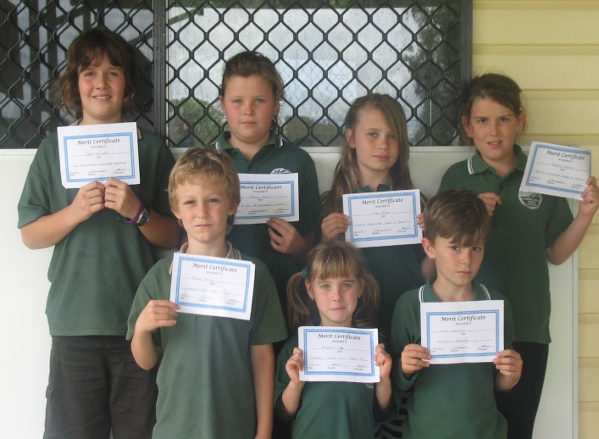 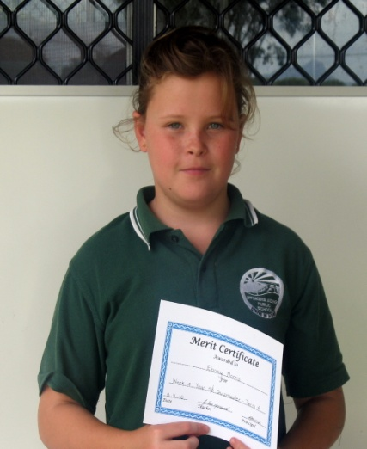

**Kindy Orientation**

Our Kindergarten Orientation program is running really well – last week we made frogs and learnt a new song called “Tadpole Blues” It’s wonderful to have such a large and enthusiastic Kindergarten group – we have 13 happy, energetic young learners starting school in 2011!

Timetable as follows:

This week (12th November) the children will be with us until 11am.

The next two weeks the children will be at school until 11.30a.m. (19th and 26th of November)

On the 3rd of December the children will stay and have Fruito and morning tea with us, until midday.

On the 10th of December this will be extended to lunchtime (1.30p.m.) depending on how we settle in.

The aim of our orientation program is to make starting at “big school” a happy, relaxed and worry-free time for all.

Mr Killion.

**Canteen News**

Canteen Roster for Friday 12th Nov – Debby & Sonia

**C:\Program Files\Microsoft Office\Media\CntCD1\ClipArt1\j0174383.wmfMore volunteers needed.**

**End of Year DISCO**

The P&C will be hosting a “Hawaiian” themed disco on **26th Nov at 6.30pm** in the Hall. Come dressed in your best beach or Hawaiian wear. Cost will be $6 each.

**Children’s Christmas Celebration 2010.**

On Friday, 10th December, our School will have a special Christmas Celebration between 12.30 and 1.30. We are one of ten public schools to host this Tweed Coast community initiative, in its fourth year. The whole of school programme will include an assembly and three learning centres, celebratory songs, activities, DVD and craft with the theme “For The World”, including references to Christ and Christmas, along with the giant earthball. There will be no cost to our School or Students. If you do not wish your child/children to attend, please advise the School.

**Community News**

**Junior Cricketers**

Under 16-14-12

Beginners Under 10 – Training Rabjones Oval Murwillumbah Tue/Thur 3.45-5.15 Membership Fee $90 Further details

Phone: 66770186

**Southern Cross Cultural Exchange**

We are seeking volunteer host families for selected international exchange students from European countries, the USA and Japan arriving in early February. Match a student to your family.

Ring 1800500501 or [scceaust@scce.com.au](mailto:scceaust@scce.com.au)

**House to rent: farm house on house block for rent in Stokers Siding. Phone 0400415167**

Richard Killion

(Relieving) Principal

**C:\Program Files\Microsoft Office\Media\CntCD1\Animated\j0303338.gifTrivia Day Photos**

C:\Program Files\Microsoft Office\Media\CntCD1\ClipArt2\j0232171.wmf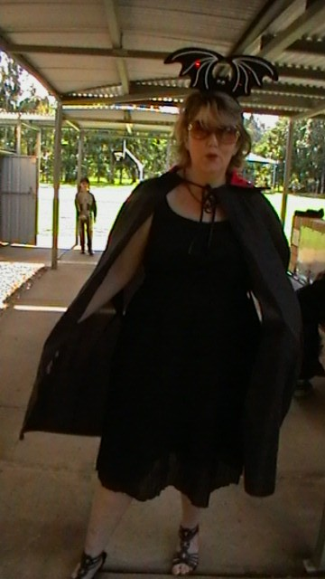C:\Program Files\Microsoft Office\Media\CntCD1\ClipArt1\j0078788.wmf