

**STOKERS SIDING SCHOOL**

**NEWSLETTER**

Email address: stokerssid-p.school@det.nsw.edu.au

Web Page: http://www.stokerssid-p.schools.nsw.edu.au/Index.html

**Term 4 Week 6 - Wednesday 17th November 2010**

|  |  |  |  |
| --- | --- | --- | --- |
| **DATE** | **EVENT** | **WHO** | **ACTION** |
| **15/10/10** | **AFL Clinic**  **12 – 1.30**  **(6 week program)** | **All classes** | **Joggers or school shoes** |
| **17th-18th November** | **Borrowing from the Library will cease this week** | **All students** | **Please return any Library books.** |
| **03/12/10** | **Boardies and Beach day and Art Gallery excursion** | **All classes** | **More details next week.** |

**PRINCIPAL’S MESSAGE**

What a fantastic response we had to our Coles Sports for Schools voucher collection. Many thanks to Debby for co-ordinating the collection, counting and return of the vouchers. We collected an amazing **10,138** vouchers, which is an outstanding success! Mr Hollis and Mr Killion have checked the catalogue and we will certainly be able to choose some great equipment. Well done everyone and thank you!

Today (Monday) we welcomed Kyla and Lucy van Dooren and their mother Beth to our “small school, big family”. Kyla is in Kindergarten and Lucy is in Year 1. We hope you enjoy your time with us!

Unfortunately the K-3 excursion that was to be held on Wednesday has had to be postponed. Our plan is now to include the whole school in the excursion and it will take place on Friday 3rd December, which is also our “Boardies and Beach Day”, a fundraiser for Australian Surf Lifesaving. We are hoping to travel on from the Art Gallery to Pottsville or Duranbah for some sand modelling, beach games and a sausage sizzle, to really make the most of the day. Further details will be sent home in next week’s newsletter. A huge thank you to everyone for supporting Mr Killion in my unexpected recent absence. Thank you again to Mr Killion who does a brilliant job in the Principal role.

**Merit Awards**

Congratulations to our Merit Award winners for this week – Manon McDuffie, Sharleah Parry, Kyla Van Dooren, Lucy Van Dooren, Tazmin White, Tahneyah Van Zanden and Micheal Woodgate. Special congratulations to **Kahani Flanagan** who is our Student of the Week.

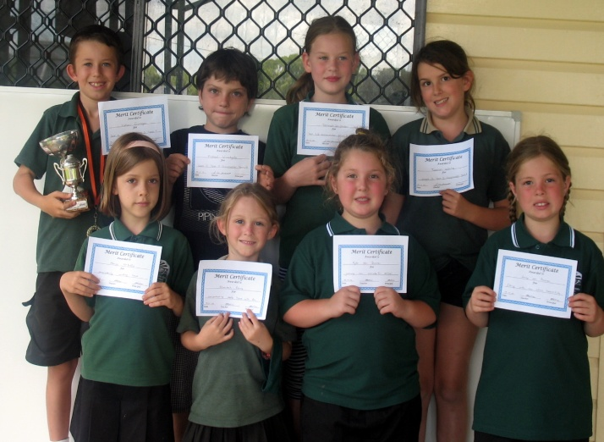 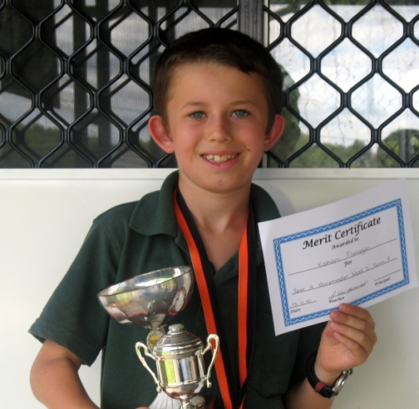

**Kindy Orientation**

Our Kindergarten Orientation program is running really well – last week we did some colour recognition and counting activities and we heard about Mr McQuire’s eggs. It’s wonderful to have such a large and enthusiastic Kindergarten group – we have 13 happy, energetic young learners starting school in 2011!

Timetable as follows:

For the next two weeks, the children will be at school until 11.30a.m. (19th and 26th of November)

On the 3rd of December we hope to include our new Kindergarten children in our Boardies and Beach day activities.

On the 10th of December the children will be staying until lunchtime (1.30)

The aim of our orientation program is to make starting at “big school” a happy, relaxed and worry-free time for all.

This Friday AT 10A.M we will be having a visit from Cheryl Baxter who will talking to the children about nose blowing and activities to promote nose breathing rather than open mouthed breathing.

**PARENTS WELCOME TO ATTEND.**

Mr Killion.

**Canteen News**

**C:\Documents and Settings\Administrator\Local Settings\Temporary Internet Files\Content.IE5\L2GBN153\MC900352115[1].wmf**

Canteen Roster for Friday 19th Nov – Debby & Rohan

**More volunteers needed.**

**New items –**

**Byron Bay Bottled Water $2**

**Lanyards straps (carry bottles) $1**

**Rice Cakes .80c**

**No Mini Milos**

**Thank you to Sonia, Rohan and Ken who have helped out in the canteen recently.**

**C:\Program Files\Microsoft Office\Media\CntCD1\ClipArt1\j0174383.wmf**

**End of Year DISCO**

The P&C will be hosting a “Hawaiian” themed disco on **26th Nov at 6.30pm** in the Hall. Come dressed in your best beach or Hawaiian wear. Cost will be $6 each.

**Children’s Christmas Celebration 2010.**

On Friday, 10th December, our School will have a special Christmas Celebration between 12.30 and 1.30. We are one of ten public schools to host this Tweed Coast community initiative, in its fourth year. The whole of school programme will include an assembly and three learning centres, celebratory songs, activities, DVD and craft with the theme “For The World”, including references to Christ and Christmas, along with the giant earthball. There will be no cost to our School or Students. If you do not wish your child/children to attend, please advise the School.

**C:\Program Files\Microsoft Office\Media\CntCD1\Animated\j0283542.gif**

**LIBRARY NEWS**

**Congratulations to the following students for their efforts in borrowing books from the Library this year.**

10 BOOKS – Erez, Tahlia, Ginger, Sharleah, Finn B & Tahneyah

**20 BOOKS – Paris, Aurin, Ariela, Murayah, Lionel, Dalton, Mia and Connor**.

Mr Hollis

**C:\Program Files\Microsoft Office\Media\CntCD1\ClipArt3\j0233292.wmf**

**Year 6 Farewell**

**Monday December 13th**

As we only have one student in year six this year, the year 5 students will join Jessica for the farewell dinner. This year the students have chosen to go 10 pin bowling in Tweed and then to the Pizza Hut in Kirra. We will need 3 parents to attend and help out with transport. If you want to attend please let Ange or Marg know ASAP. **Cost and more details in next week’s newsletter.**

**Community News**

**Dental Visits**

The schools do not have Dental Care visits anymore however, if

parents want dental care advise please ring 1300 651 625

Marg Eaton

Principal